How to Sanitize With Bleach

Dilute mixtures of Chlorine Bleach and water are a common and cost-effective method for sanitizing equipment in food processing operations. When used properly, chlorine bleach can be a very effective method of killing undesirable microorganisms.

Sanitizing With Bleach
The best way to use bleach as a routine sanitizer is to really understand what is needed in terms of strength. You should always refer back to your master cleaning guide or Standard Operating Procedure manual for proper sanitizer strength to be used.

Why Use Test Strips?
The answer is simple: you don't always get bleach solutions of the right strength, even if you follow mixing instructions. What causes this? Sometimes water used for bleach preparation contains natural chemicals that work to weaken the bleach and sometimes the bleach itself has lost strength. If you use bleach that is too weak, you are not killing bacteria!
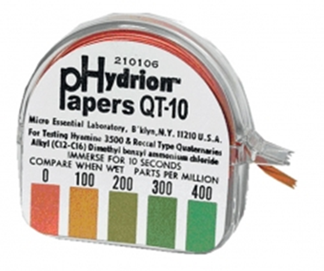
Health inspectors often look for bleach sanitizer solutions to have a minimum of 50 PPM concentration. The most common practice requires 100PPM bleach and water sanitizer solution.

How to Mix and Use Bleach Solutions
Normally, one tablespoon ( = 15 milliliters = 0.5 liquid ounce) of concentrated bleach per gallon of water at normal room temperature is considered to be the equivalent of 200 PPM. This is the standard for cleaning food preparation surfaces. Cleaning equipment requires a higher concentration than utensil rinse or treatment of food preparation equipment

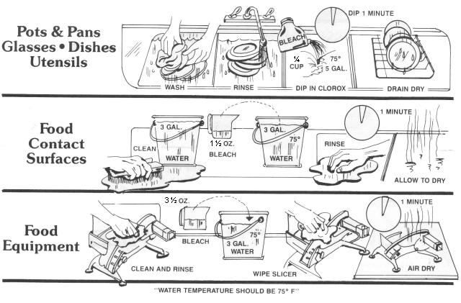
As you can see in these simplified instructions, there are some constant procedures.
- First, the temperature has to be right (75 Degrees Fahrenheit) hotter temperatures decrease the effectiveness of bleach solutions.
- Second, the time of exposure has to be at least one minute for a bacterial kill.
- Third, and perhaps most important, the concentration of chlorine MUST BE ADEQUATE.

Here is a guideline for mixing bleach solutions:
Sanitizing Activity | Ratio | Should Test to Minimum PPM | If Low / If High
Pots, Pans, Dishes and Utensils | 2 ounces/ 5 gallons (~0.3%) | 50-100 PPM | Add Bleach/Add Water
Food Contact Surfaces | 1.5 ounces/ 3 gallons (~0.4%) | 100 PPM | Add Bleach/Add Water
Food Processing Equipment | 3.5 ounces/ 3 gallons  (~1%) | 200 PPM | Add Bleach/Add Water

The contact times usually are from 1 – 5 minutes which is usually sufficient to achieve a complete sanitation of the area, depending on the chlorine bleach concentration.
If higher concentration are used than those listed above, the surface may need to be rinsed using clean potable water.

CAUTION: DO NOT MIX CHLORINE BLEACH WITH ANY OTHER CHEMICAL. A CHEMICAL REACTION MAY OCCUR THAT COULD BE HAZARDOUS TO YOUR HEALTH!

